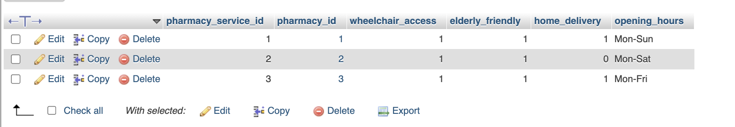
Stores branch-level pharmacy service and accessibility settings. Each pharmacy_service_id is linked to a pharmacy_id and records wheelchair_access, elderly_friendly, home_delivery, and opening_hours. The visible rows show all three pharmacies as wheelchair accessible and elderly friendly, while home delivery and opening days vary by branch. This compact structure allows patient-facing pharmacy selection to consider service capabilities and operating patterns in addition to stock availability and location.

Serves as the main electronic prescription header. Each prescription_id has a prescription_code and links a patient_id with a doctor_id, while prescribed_at and status record issuance and verification state. Sensitive diagnosis and clinical notes are stored in diagnosis_encrypted and clinical_notes_encrypted, and digital_signature plus created_at and updated_at support integrity and lifecycle tracking. The visible prescriptions are marked Verified, with encrypted clinical fields present on the newer records.

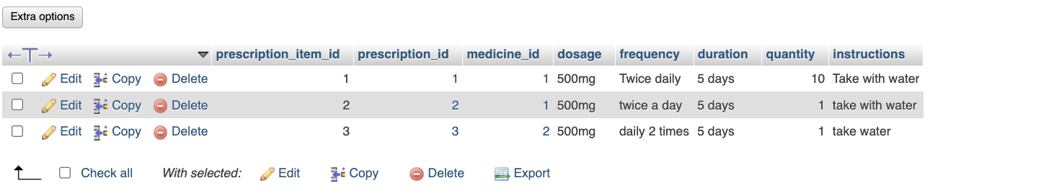
Contains the medication line items belonging to each prescription. Each prescription_item_id links to a prescription_id and medicine_id and records dosage, frequency, duration, quantity, and patient instructions. The visible examples include 500 mg courses with different frequency wording and five-day durations. Separating these rows from the prescription header allows one prescription to contain one or more medicine regimens while retaining the exact instructions and quantity required for each prescribed medicine.

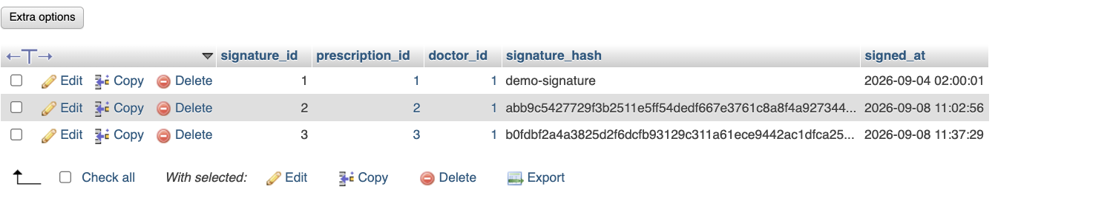
Stores prescription signature records separately from the prescription header. Each signature_id is linked to a prescription_id and doctor_id and contains a signature_hash and signed_at timestamp. The sample rows correspond to the three visible prescriptions and preserve a signature value for each. This provides a dedicated record showing which doctor signed a prescription, the stored signature digest, and the time at which the signature was applied.

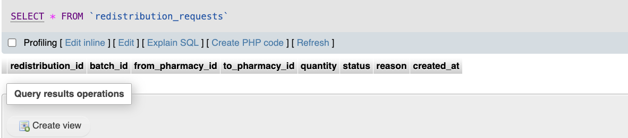
Supports pharmacy-to-pharmacy stock redistribution requests. The schema records redistribution_id, batch_id, from_pharmacy_id, to_pharmacy_id, quantity, status, reason, and created_at. The supplied screenshot currently shows no redistribution rows, but the fields allow a specific batch quantity to be moved from one pharmacy to another and the request to be tracked with a status and reason. Using batch_id also preserves lot-level traceability during a transfer.

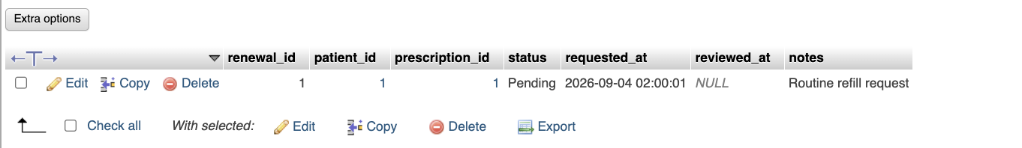
Stores patient prescription renewal requests. Each renewal_id links a patient_id and prescription_id, with status, requested_at, reviewed_at, and notes capturing the request lifecycle. The visible example is a Pending routine refill request whose reviewed_at field is still NULL. This structure allows a patient to request continuation of an existing prescription while keeping the original prescription reference and a clear audit trail of when the request was made and later reviewed.

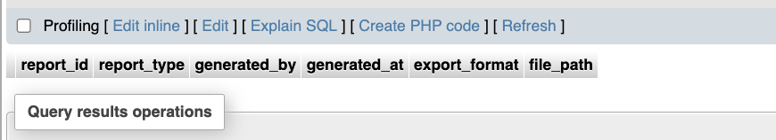
Provides a register for generated system reports. Its fields are report_id, report_type, generated_by, generated_at, export_format, and file_path. The current screenshot contains no report rows, but the schema supports recording what report was created, who generated it, when it was generated, the output format, and where the exported file was stored. This gives administrative reporting a persistent metadata record without storing the full report contents directly in the table.

